# Device Audit Status

## Definitions

### Device Audit Status

A device attribute named Audit Status.

Possible values are Not Verified / Verified / Verified - New / Absent / Verified Error.

#### Not Verified

When a new audit is created (Manually), the device audit status of all devices will be set to Not Verified. If the audit is generated in Work Order, then keep the audit status.

#### Verified

When a user select a device / cable and clicks the Validate button in MAM, the device audit status of this device / cable will be set to Verified.

#### Verified - New

When a device / cable is created during an audit in MAM, the device audit status of this device / cable will be set to Verified - New.

#### Absent

When a user select a rack / device / cable and clicks the Absent button in MAM, the device audit status of this device / cable will be set to Absent.

#### Verified - Error

1. For a rack

If the device audit status of any device in this rack is set to Verified - New / Absent / Verified - Error, the device audit status of this rack will be set to Verified - Error.

1. For an enclosure

If the device audit status of any blade device in this enclosure is set to Verified - New / Absent / Verified - Error, the device audit status of this enclosure will be set to Verified - Error.

1. For a device

If the device audit status of any cable of this device is set to Verified - New / Absent / Verified - Error, the device audit status of this device will be set to Verified - Error.

### Status of Audit

Possible values are Not Started / In Progress / Complete / Complete with Error.

#### Not Started

When an audit is newly created, the status of this audit is Not Started.

#### In Progress

If the device audit status of any rack / device / cable in this audit is set to Verified, the status of this audit is In Progress.

#### Complete

Per the manually created audit, if the device audit status of all racks in this audit are set to Verified, the status of this audit is Complete.

Per the generated audit in WO, if the device audit status of all devices/cables related to the Work Order are set to Verified, the status of this audit is Complete.

#### Complete with Error

For both manually created audit and generated audit in WO, if the device audit status of any rack/device/cable is set to Verified - New / Absent / Verified - Error, the status of this audit is Complete with Error.

## New Audit (Manually created or generated in WO)

Device audit status of all devices in the audit will be set to Not Verified when an audit is created manually. If the audit is generated in Work Order, then keep the audit status.

### Event entry in Calendar.

#### Event Name:

Audit Status Changed

#### Description:

Device Audit Status changed from [OLD_STATUS] to [NEW_STATUS]

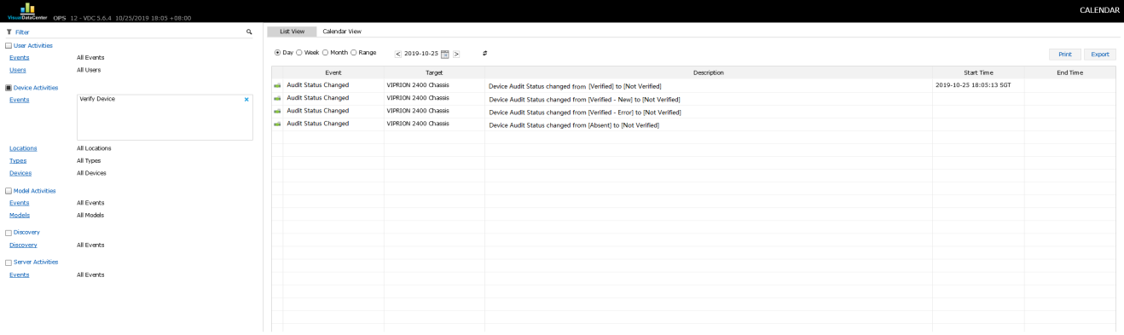

## Verify Rack

#### Description

Per manually created audit, need device audit status of all devices* in this rack are Verified.

[all devices] in this case are Operational devices.

Device audit status of the rack is set to Verified.

#### Manually created audit

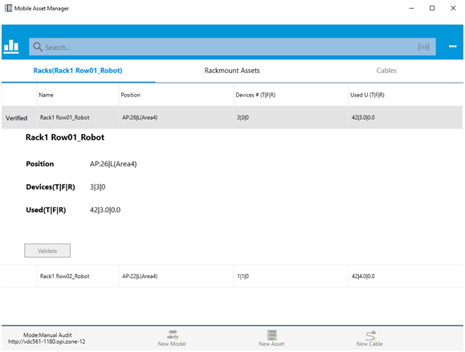

#### Generated audit in Work Order

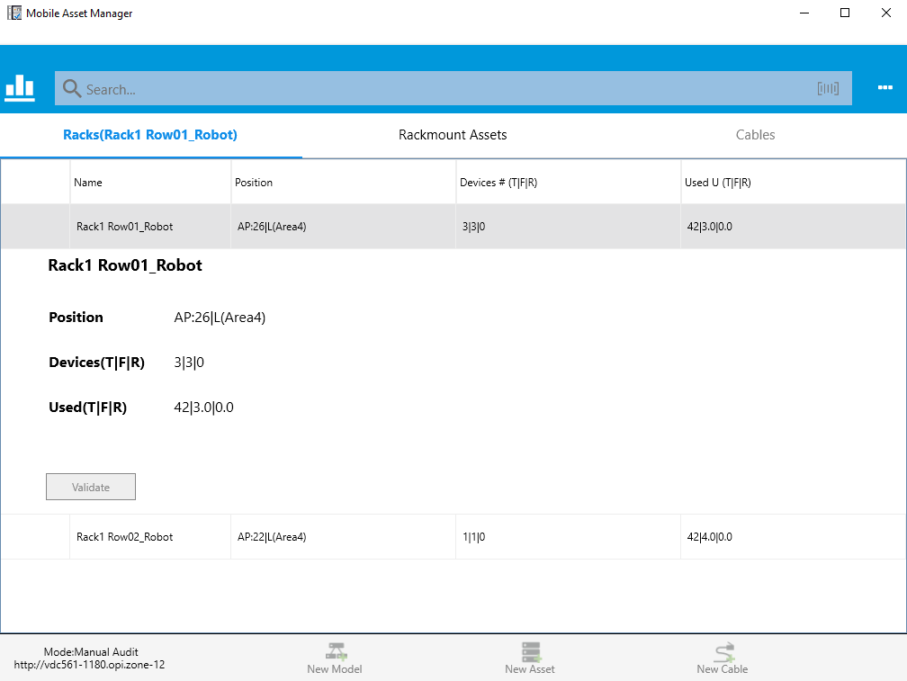

#### Event entry in Calendar.

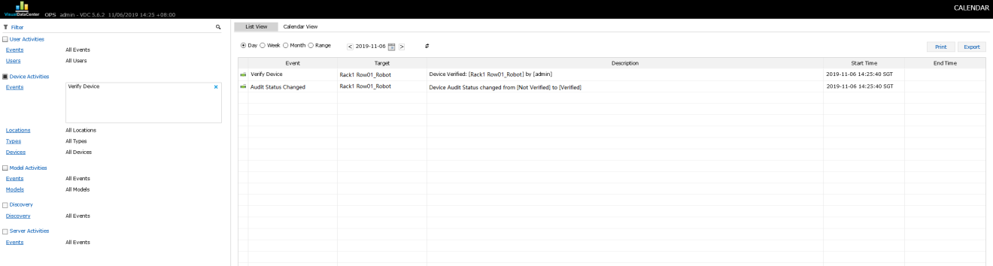

## Verify Device

#### Description

There are cable types required to be verified or not (based on the option defined when a new audit is created) before this device is verified.

#### Event entry in Calendar.

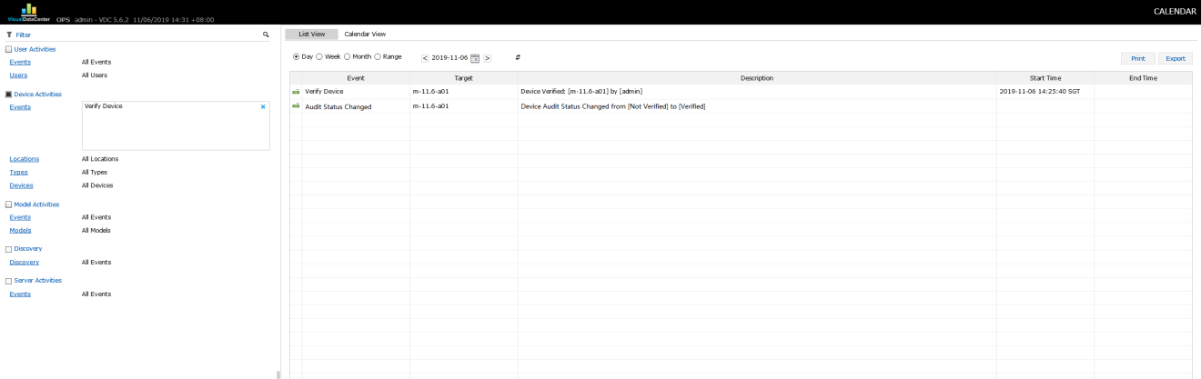

#### In MAM

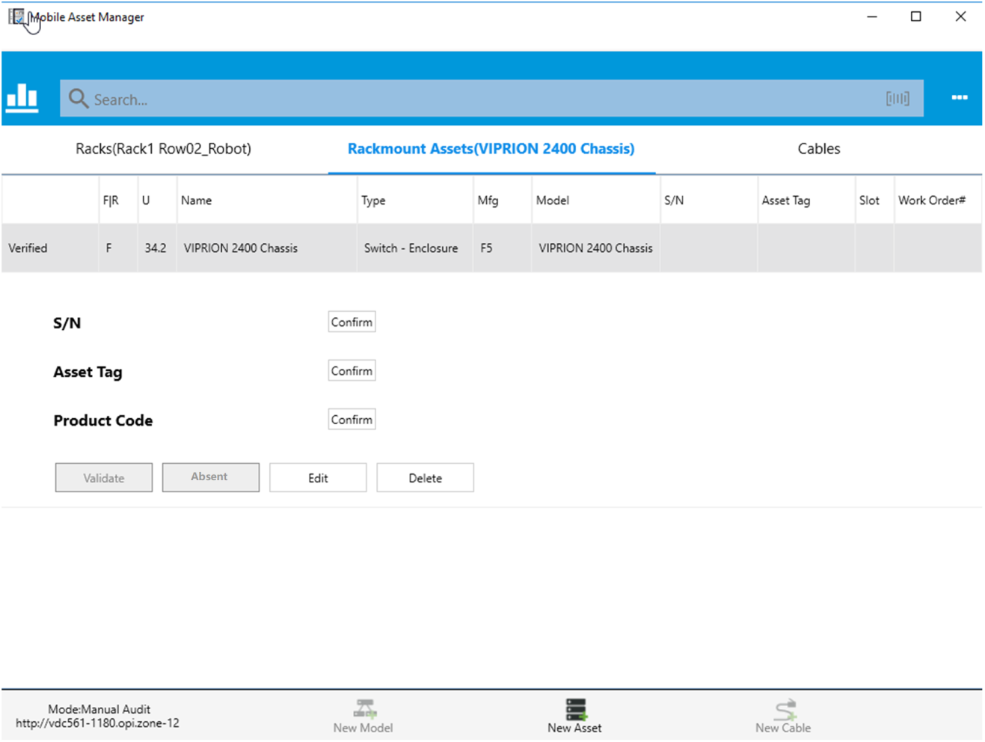

## Verify Cable

#### Description

Set audit status of cable to Verified

#### Event entry in Calendar

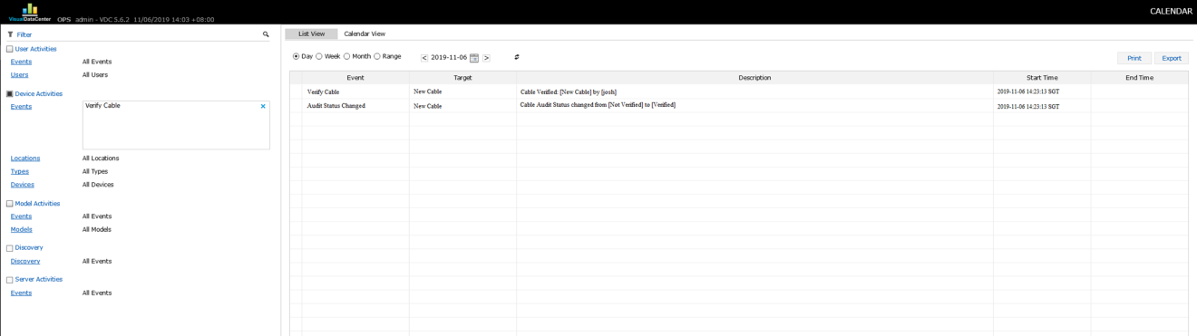

#### In MAM

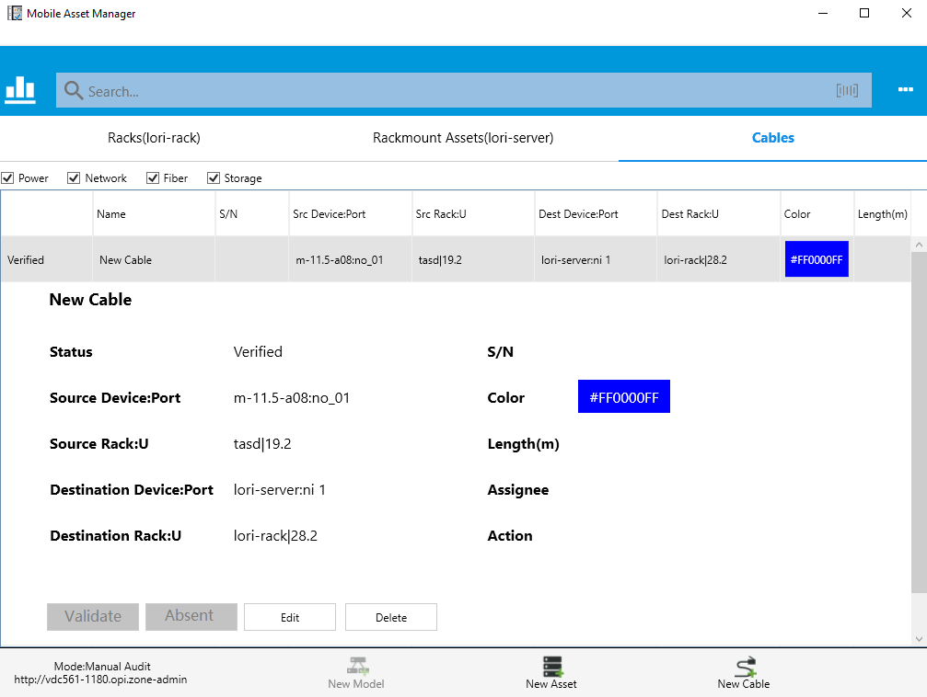

## Verified - New

### Device

Create Device in MAM. Filling the form in New Asset page and submit.

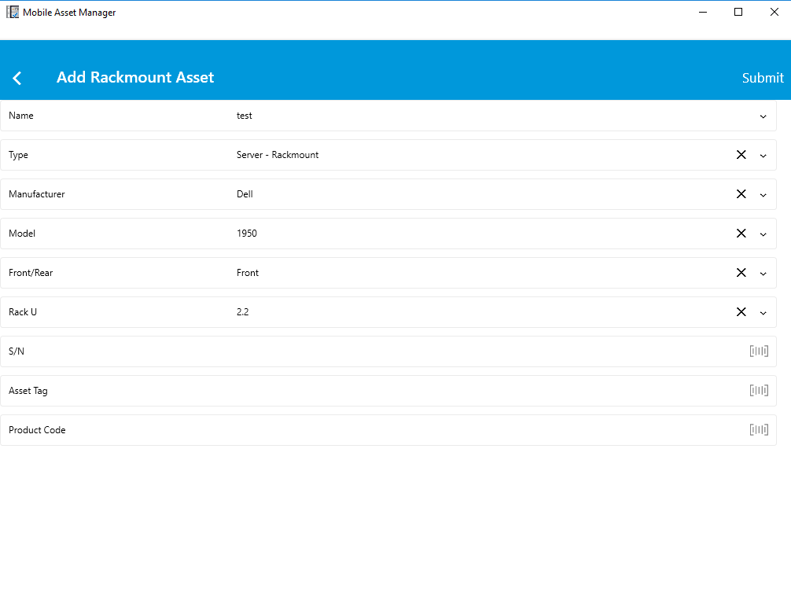

#### Event entry in Calendar

* target device audit status changed event
* container rack audit status changed event

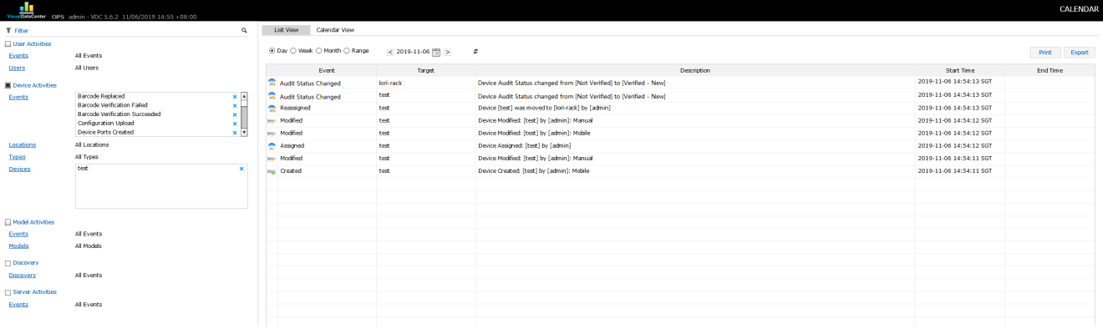

#### In MAM

##### Device audit status

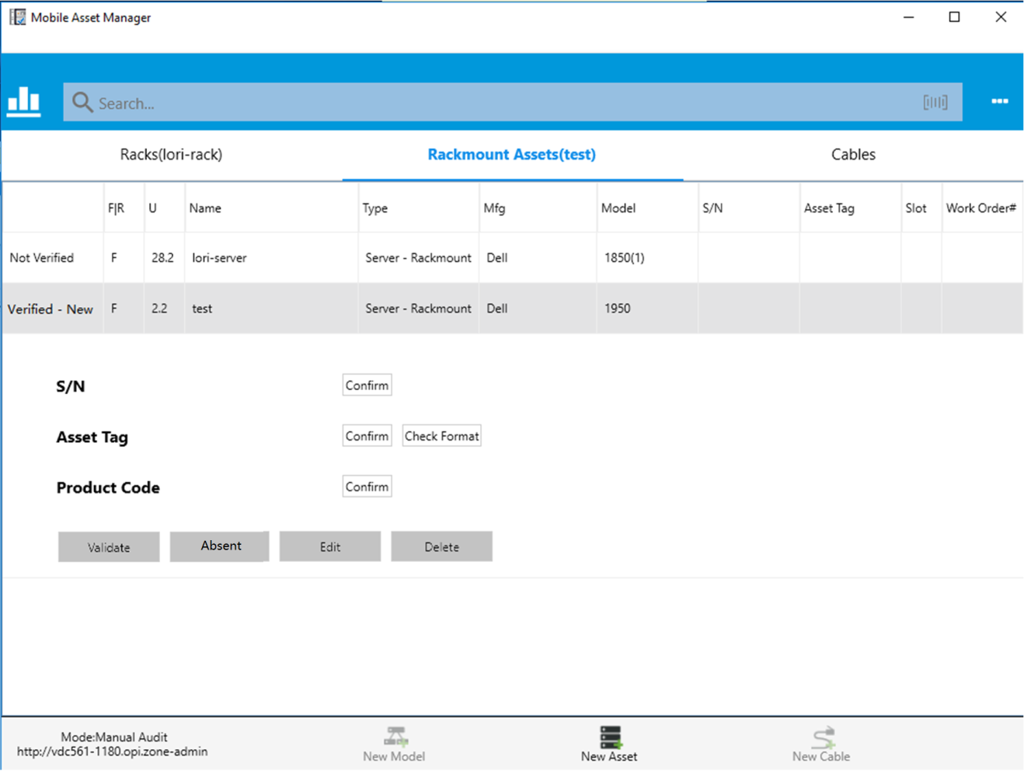

##### Container Rack audit status

#### Status of Audit

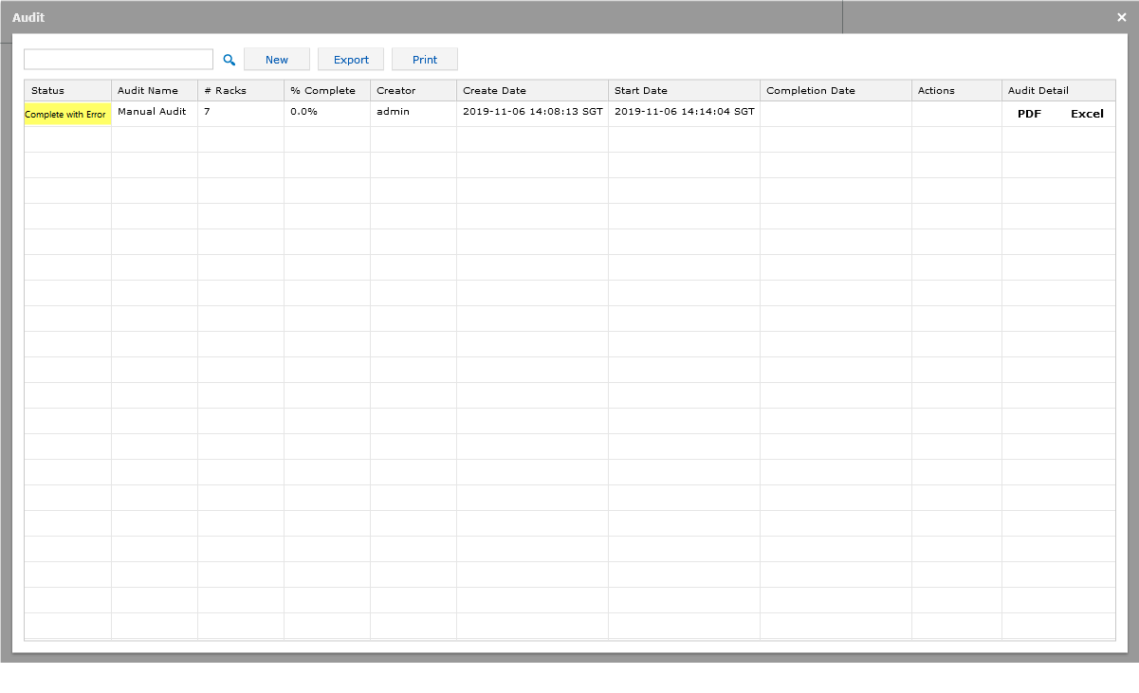

### Cable

Create cable in MAM, filling the form in Add Cable page and submit

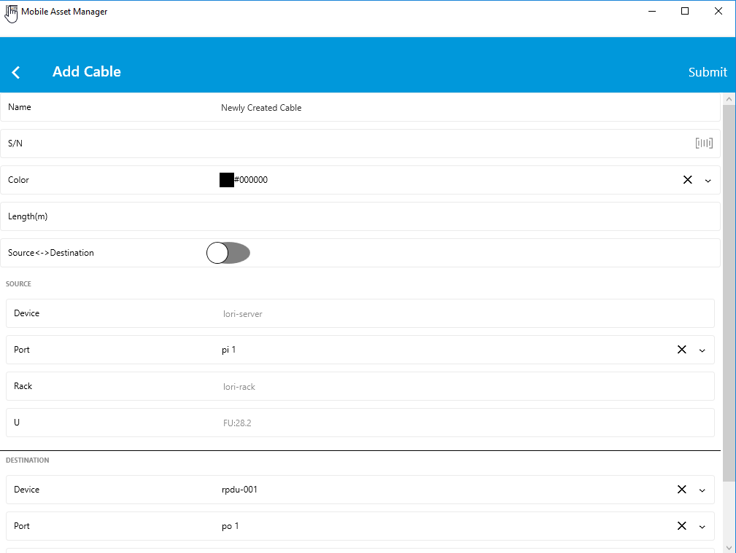

#### Event entry in Calendar

* Cable audit status changed event
* Device audit status changed event
* Container rack audit status changed event

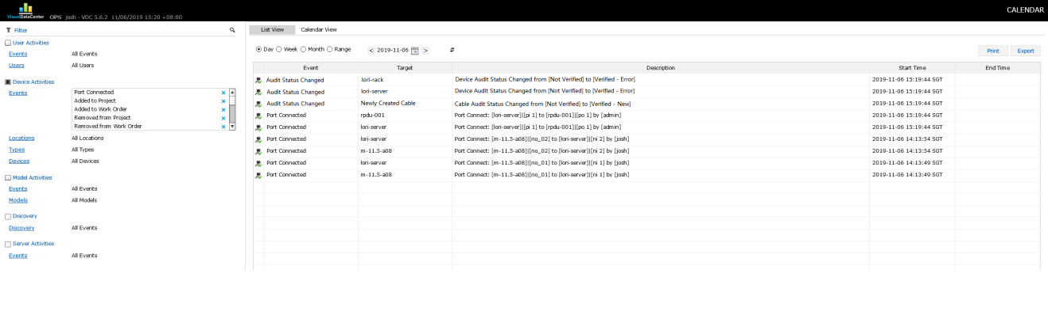

#### In MAM

##### Cable audit status

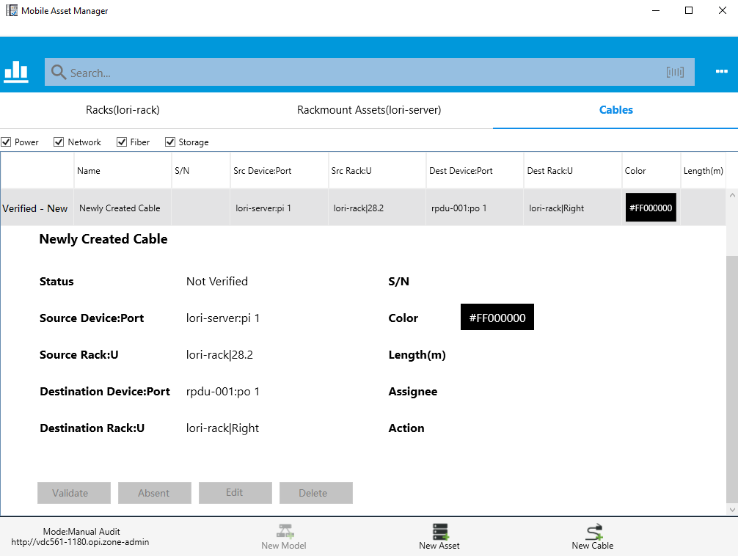

##### Device audit status

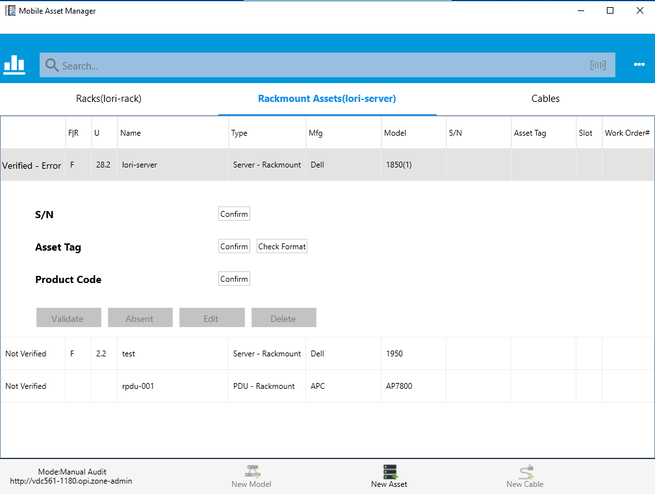

##### Container Rack audit status

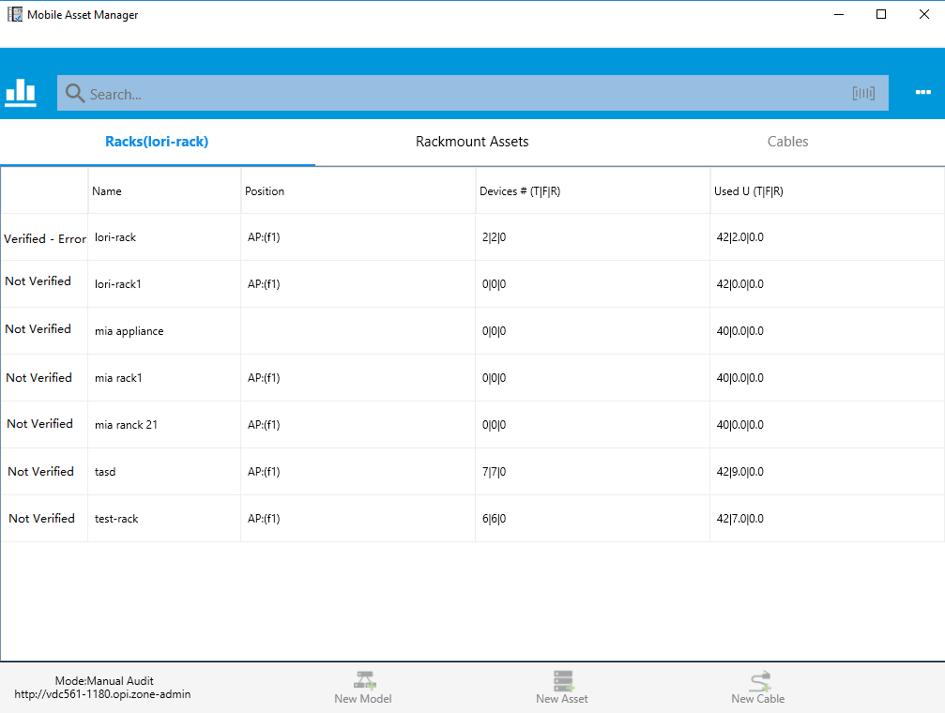

#### Status of Audit



## Absent

### Device

Click Absent button to set the audit status to Absent in device detail panel.

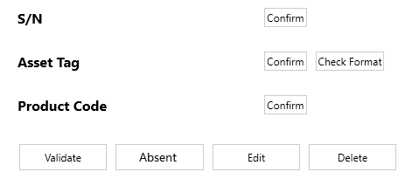

#### Event entry in Calendar

* Device audit status changed event
* Container Rack audit status changed event

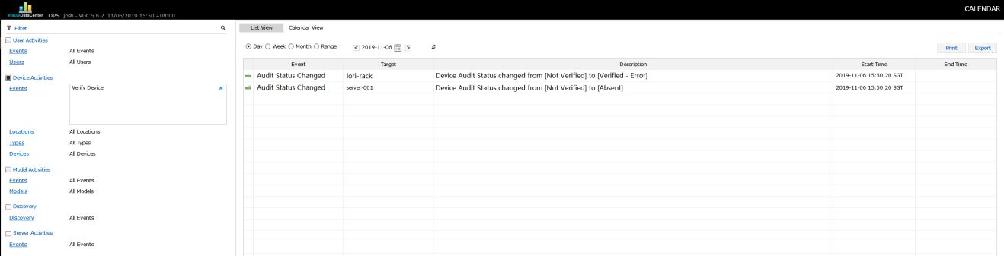

#### In MAM

##### Device audit status

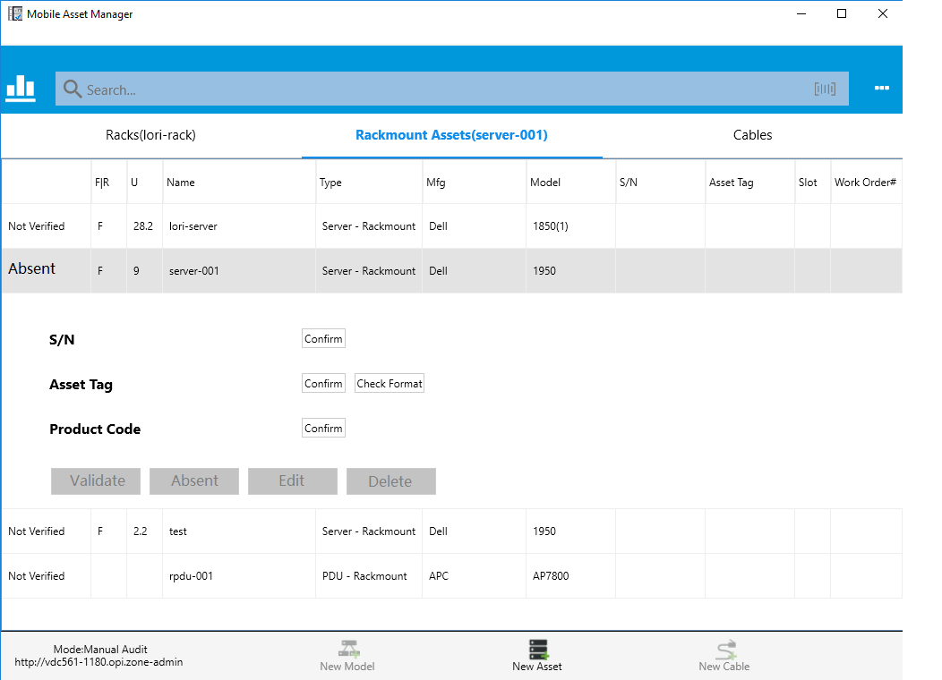

##### Container Rack audit status

#### Status of Audit



### Cable

Click Absent button to set audit status to Absent in the cable detail panel.

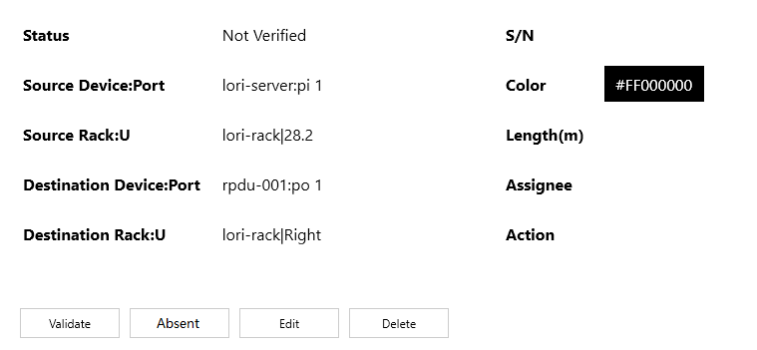

#### Event entry in Calendar

* Cable audit status changed event
* Device audit status changed event
* Container rack audit status changed event

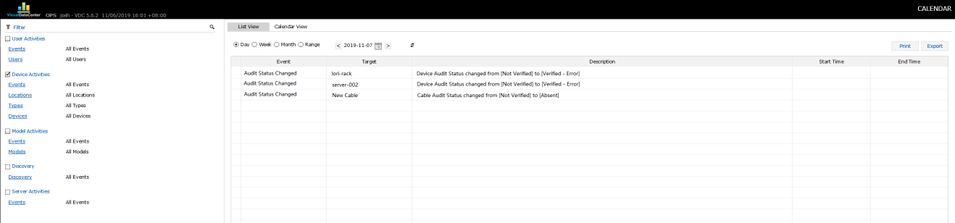

#### In MAM

##### Cable audit status

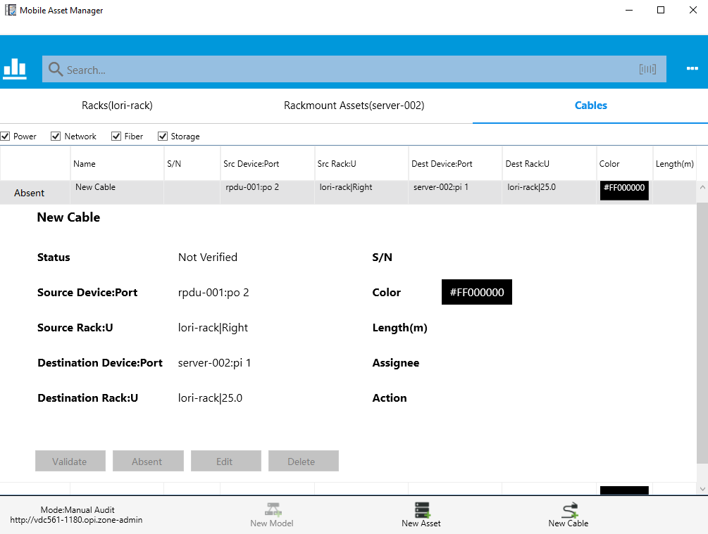

##### Device audit status

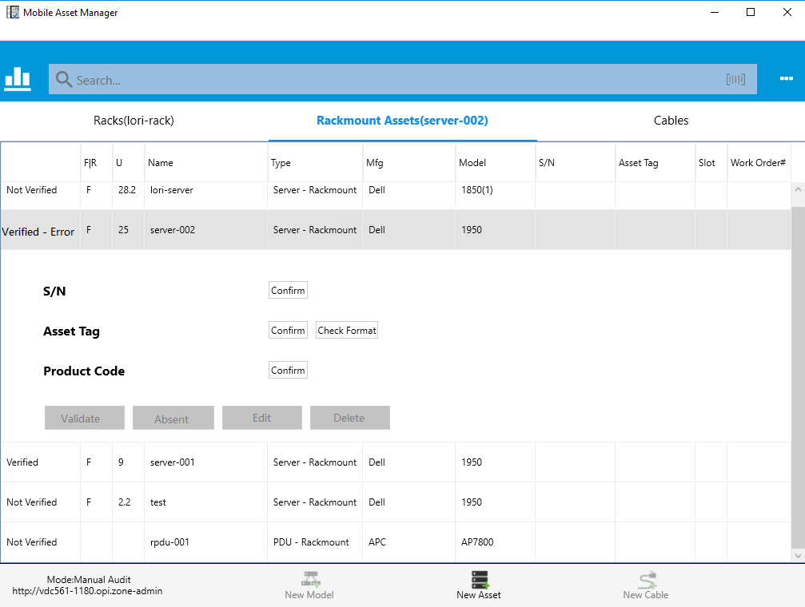

##### Container Rack audit status



#### Status of Audit

